**Annie the Musical**

The Sun Will Come Out Tomorrow……..

The sun definitely came out for The Hawthorns School of Dance, as several of our fantastic dancers gained a part in The British Theatre Academy’s production of Annie at the Leatherhead Theatre!

**Role**

Molly                                                     Lisette .M

Duffy                                                     Eloise .M

Pepper                                                 Annika .P

Drake                                                    Will .B

Chorus Orphan                                 Isla .H

Chorus Orphan                                 Emma .M

Chorus Orphan                                 Isla .S

Chorus Orphan                                 Anna .D

Chorus Orphan                          Sofia .P

Chorus Orphan                                 Lila .J

Chorus Orphan                                 Annabella .W

Female Ensemble/Cecille             Olivia .C

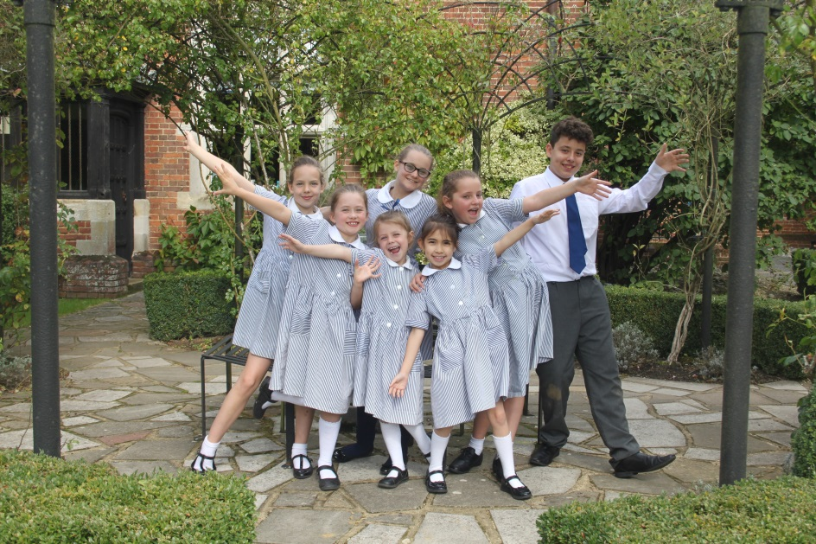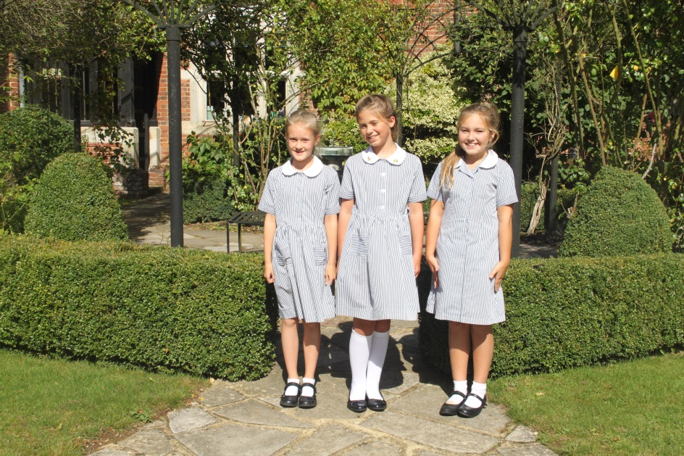

**CADS Peter Pan, Chaldon**

Congratulations to the following children who all gained parts in Chaldon’s Christmas Pantomime, Peter Pan. I look forward to watching the children over the festive period!

**Role**

Michael Darling                 William .K

John Darling Catherine .M

Wendy Darling                  Anna .D

Slightly (lost boy)             Felicity .S

Curly                                     Lizzie .B

Tottles                                  Imogen .D

Nibs                                       Isabel .P

Turk                                       Katie .B

Starkey                                 Jessica .H

Wibbles                                Ruby .J

Bones                                   Emma .M

Mullins                                 Aurelia .N

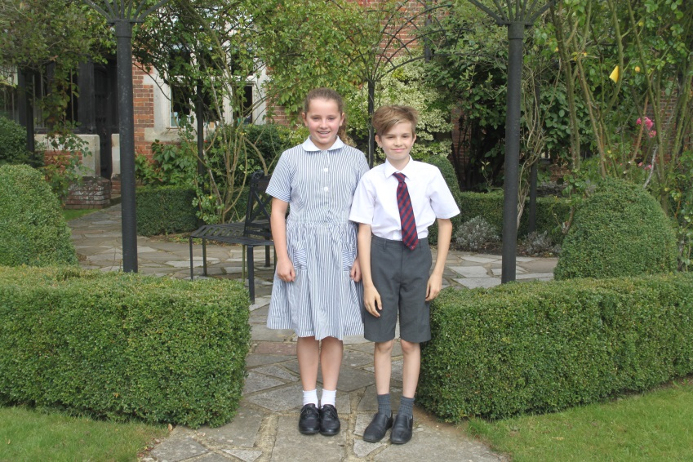

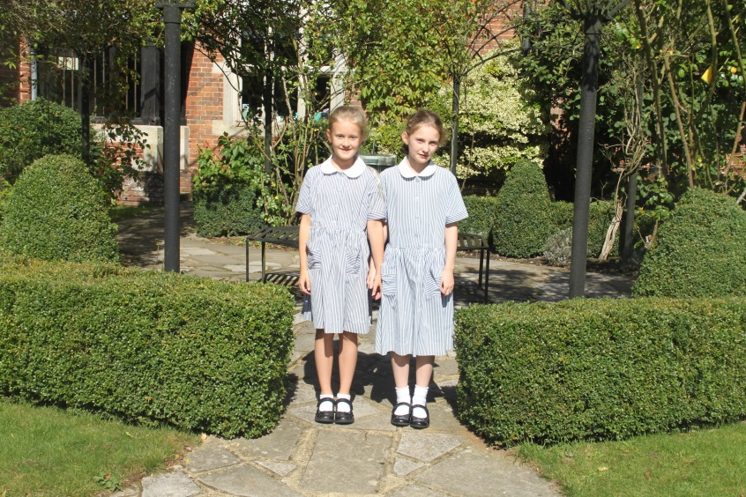

**Audition Success**

Congratulations to the following children who successfully auditioned and gained a part in The British Theatre Academy’s production of Cinderella. Sofia, William and Anna are also now fully-fledged members of the company.

Sofia .P

William .K

Anna .D

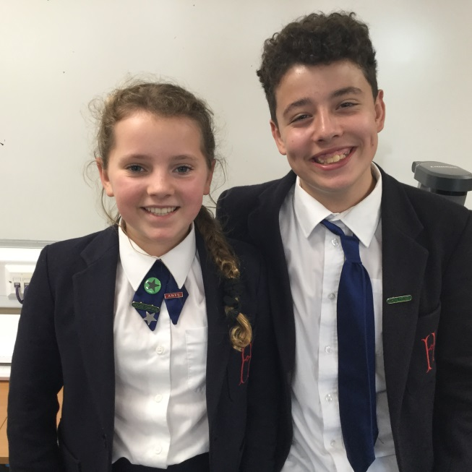 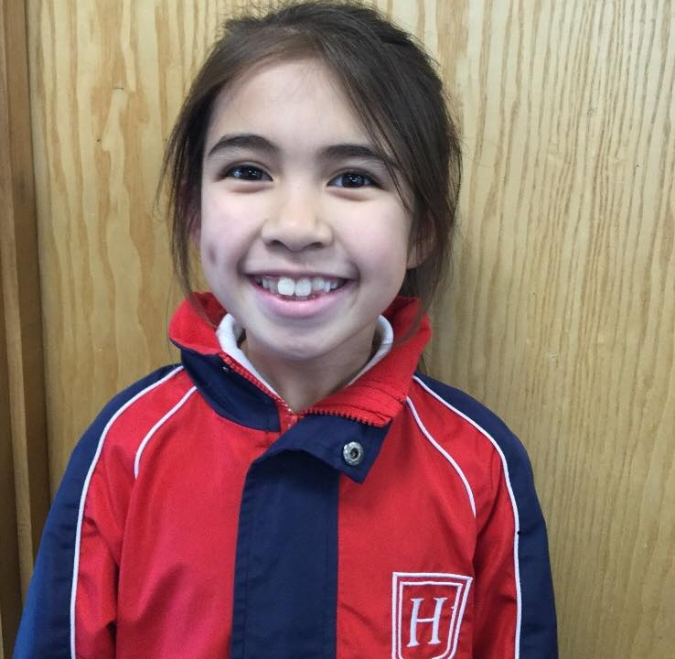

**Dorking Halls Panto News**

Congratulations to Holly.N (OH), Lalita.F-B (OH) and Freya. R (OH) for gaining parts in this year’s Dorking Halls Pantomime. They will be starring in Sleeping Beauty from 16th – 28th December 2017. I look forward to watching their performance, remember girls - lights, camera, action!

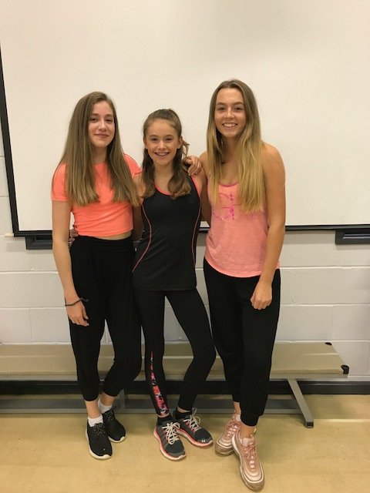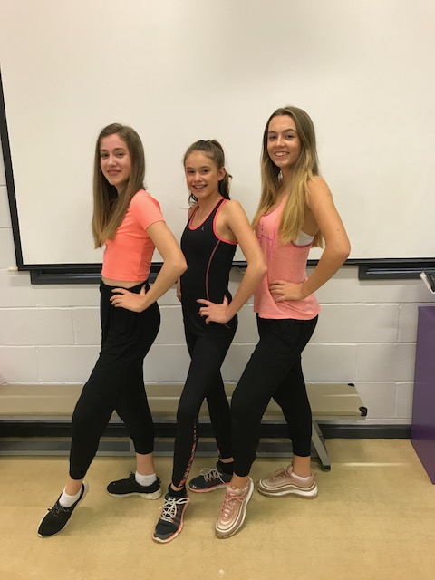

**ESOSOC Production of Annie at the Harlequin Theatre 2017**

Congratulations to Eleanor.H who will perform in the musical Annie with ESOSOC. Well done Eleanor a fantastic achievement, we are so proud of you.

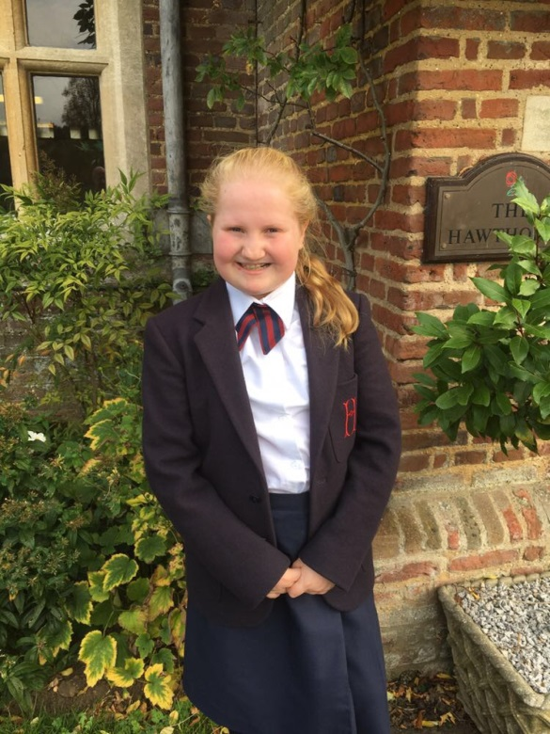

**Dance Examinations Autumn 2017**

Well done to all children who took part in our Autumn Term Examination session. The children worked extremely hard and enjoyed the experience. Fingers crossed for an outstanding set of results!

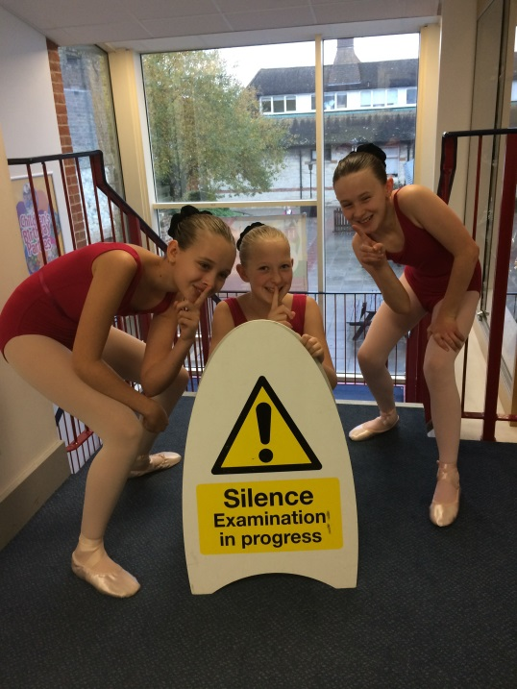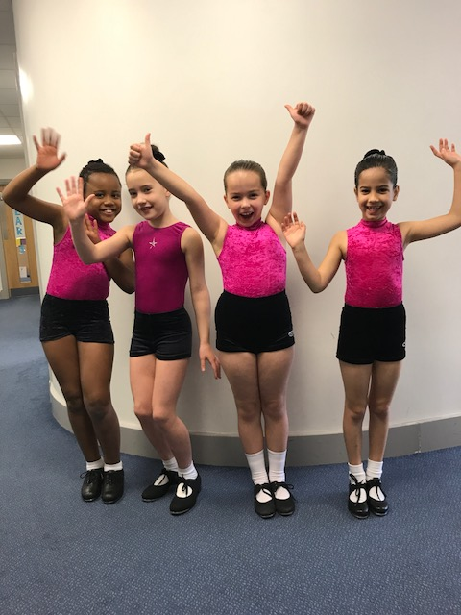

**My Ballet Examination**

When you arrive at School you need to get changed very quietly. Put on your leotard, belt, tights and ballet shoes with ribbons. Next, you have your hair done in a ballet bun using gel to make it smooth. It is best to practice quietly because there are exams going on before your exam in the Activity Room. If you are nervous that is fine because everyone gets nerves! The teacher then tells you to get in your line. You are now ready to go in to take your exam. Good Luck!

**Mia.W**

On the 17th November 2017, Mia W, Matilda W and I had our Ballet exam. I was chosen to write about what it was like. When the bell rings your legs start to shake and you slowly step into the room. At first it is a bit daunting, but then after a few seconds it all becomes reality again and then you just have to get on with it. At the end of the day you were just having fun! Thank you to Mrs Curran Mrs Greenwood and my examiner.

**Harriet.C**

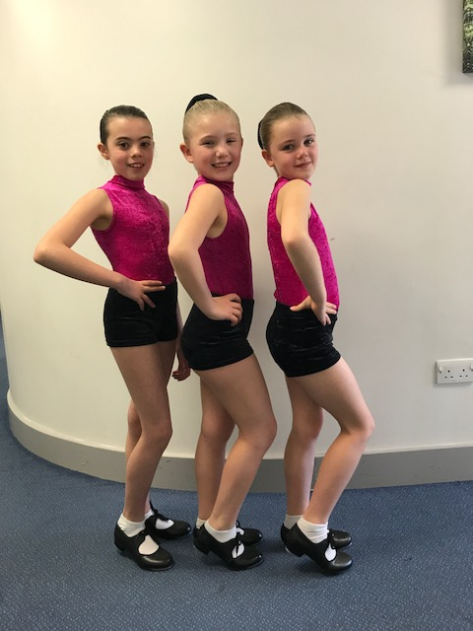

[**For each petal on the shamrock this brings a wish your way. Good health, good luck, and happiness for today and every day.**](http://www.searchquotes.com/quotation/For_each_petal_on_the_shamrock_this_brings_a_wish_your_way._Good_health%2C_good_luck%2C_and_happiness_fo/30129/)**......**

Caitin D shamrock was certainly shining this weekend as she performed in the U6’s Surrey Irish Dancing Championships. Caitin was placed in two out of three dances and was awarded 6th in the Hop Jig and 8thin the Reel. This is a fantastic achievement!! Well done.

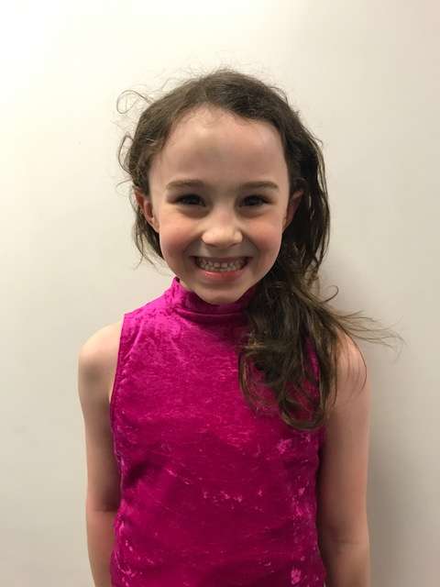

**Fee- Fi-Fo-Fum!**

**Jack & the Beanstalk Audition Success December 2017**

Congratulations to Harriet C, Isobel N, Mia W and Charlotte M who performed with Shoe String, Outwood over the Christmas holidays. The girls were taken back to the enchanted world and magical fairy-tale, of Jack & the Beanstalk. I look forward to hearing all about your performance……

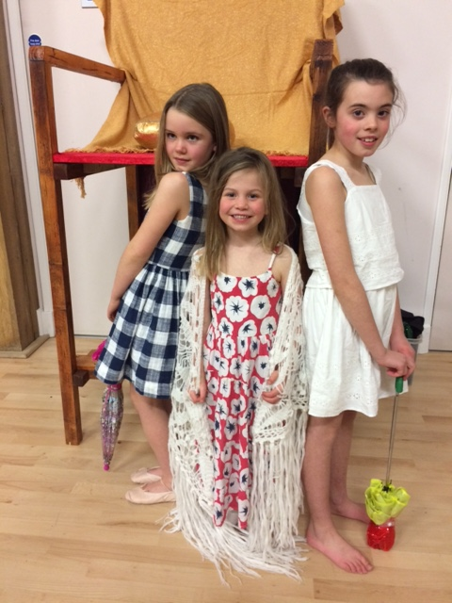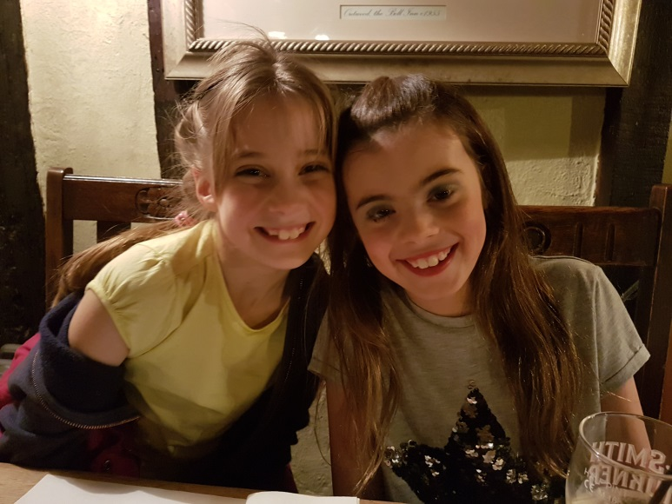

**Examination Success**

Congratulations to all of our dancers for their fantastic examination results. A special well done to, Malvika S and Gabriella G for passing their Advanced 1 Tap examination and both gaining a high Distinction!

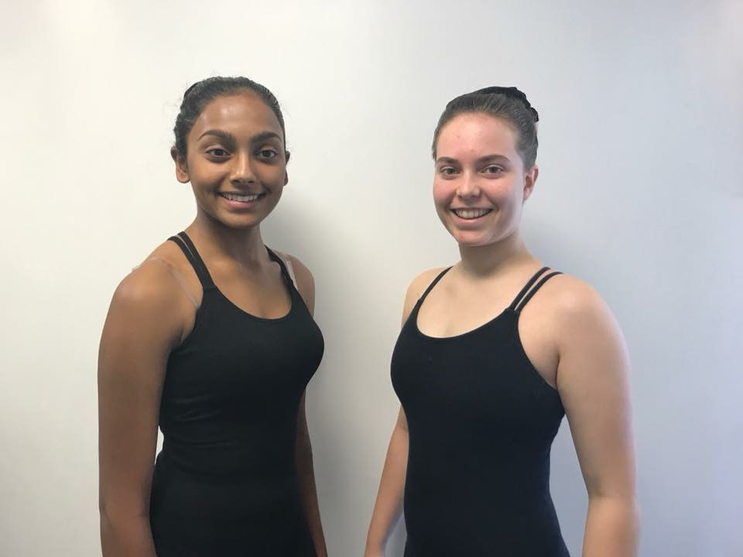

**The life of a performer!**

The panto was great fun. There were lots of people involved. I was a string bean and I had to run around the stage doing silly string stuff.

I was more confident than I thought I would be because I had done the Year 4 play. It was slightly nerve wracking but the audience seemed to love it.

**Isobel.N**

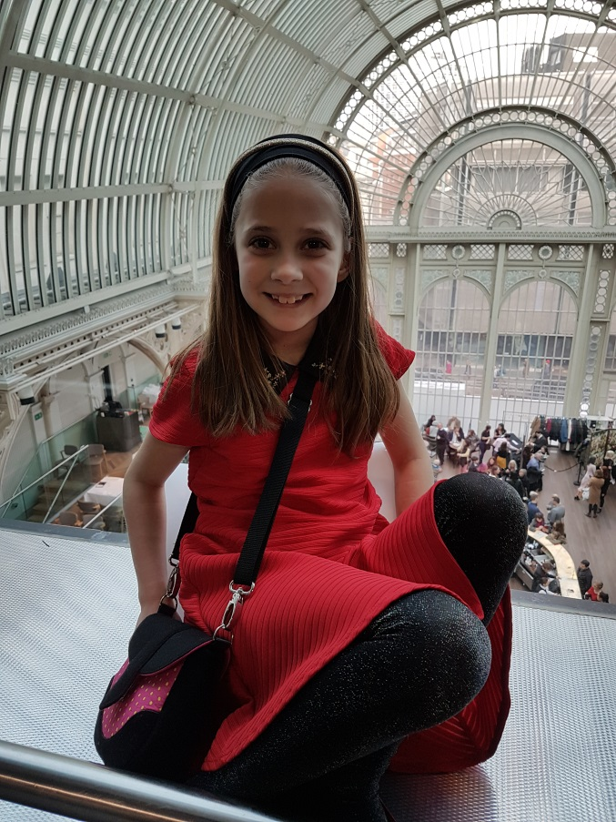

**Latin American & Ballroom Dance Sport Championships 2018**

Last weekend I went to watch the Latin and Ballroom dance sport championships. There were lots of heats that the dancers had to get through before the finals. Couples danced at the same time in big groups and were watched by judges who stood around the edge. There were hundreds of dancers.

I had tea with Jake and Alyona who are number 1 Latin showdance champions. We talked a lot about the dances. My favourite to watch and dance is the Cha cha cha. When you are older if you want to compete you have to choose between Latin and ballroom. I will definitely choose Latin.

The whole competition was amazing and Jake and Alyona were brilliant. I loved all the ladies brightly coloured dresses and hairdo’s. Alyona told me “it’s all about the dress.”

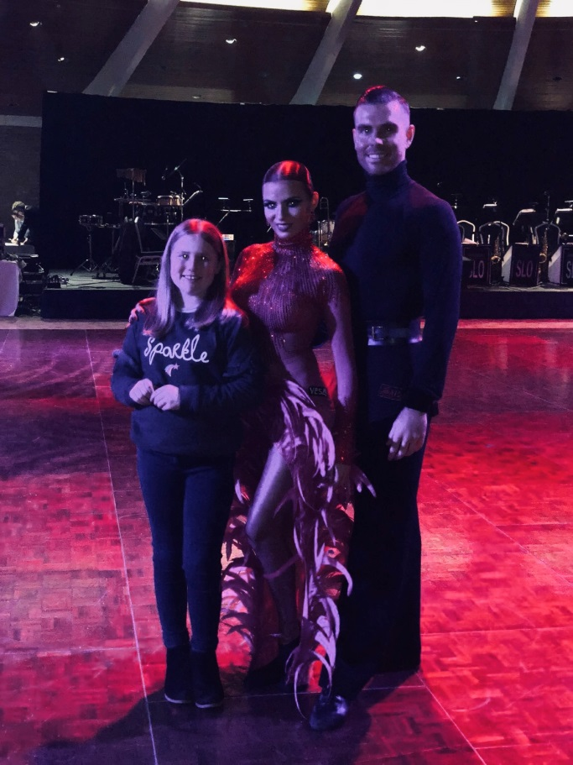

**Jenna.D**